SWIGGY SALES ANALYSIS
MS SQL SERVER QUERIES

Check for all data in swiggy_data table
SELECT * FROM swiggy_data
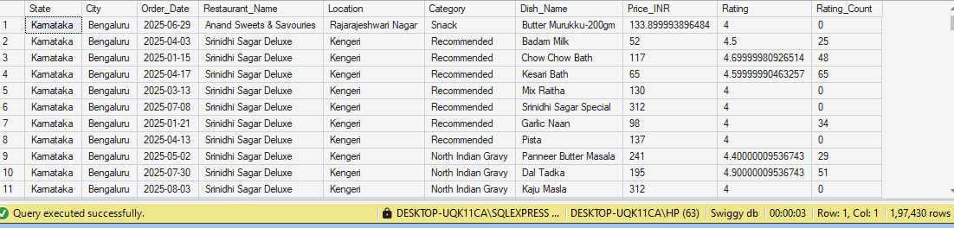

Check for all null Values in each column
SELECT
SUM(CASE WHEN State IS NULL THEN 1 ELSE 0 END) AS null_state,
SUM(CASE WHEN City IS NULL THEN 1 ELSE 0 END) AS null_city,
SUM(CASE WHEN Order_Date IS NULL THEN 1 ELSE 0 END) AS null_order_date,
SUM(CASE WHEN Restaurant_Name IS NULL THEN 1 ELSE 0 END) AS null_restaurant_name,
SUM(CASE WHEN Location IS NULL THEN 1 ELSE 0 END) AS null_location,
SUM(CASE WHEN Category IS NULL THEN 1 ELSE 0 END) AS null_category,
SUM(CASE WHEN Dish_Name IS NULL THEN 1 ELSE 0 END) AS null_dish_name,
SUM(CASE WHEN Price_INR IS NULL THEN 1 ELSE 0 END) AS null_price_inr,
SUM(CASE WHEN Rating IS NULL THEN 1 ELSE 0 END) AS null_rating,
SUM(CASE WHEN Rating_Count IS NULL THEN 1 ELSE 0 END) null_rating_count
FROM swiggy_data

--Blank & Empty Strings
SELECT * FROM swiggy_data
WHERE State= '' OR City= '' OR Order_Date= '' OR Restaurant_Name= '' OR Location= '' OR Category= '' OR Dish_Name='';
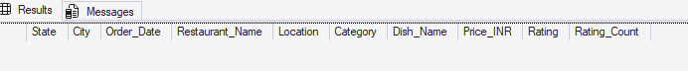
--Duplicate Detection
SELECT State, City, Order_Date, Restaurant_Name, Location, Category, Dish_Name,
Price_INR, Rating, Rating_Count, COUNT(*) AS CNT FROM swiggy_data
GROUP BY State, City, Order_Date, Restaurant_Name, Location, Category, Dish_Name,
Price_INR, Rating, Rating_Count
HAVING COUNT(*)> 1;
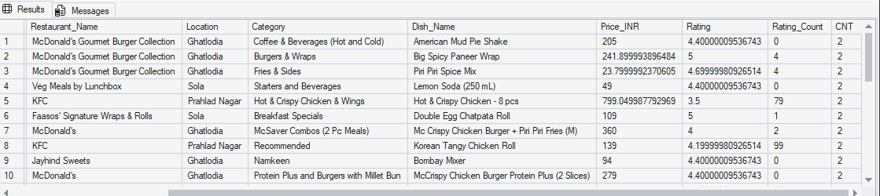

--Delete Duplication
WITH CTE AS(
SELECT *, ROW_NUMBER() OVER( PARTITION BY State, City, Order_Date, Restaurant_Name, Location,
Category, Dish_Name, Price_INR, Rating, Rating_Count ORDER BY (SELECT NULL)) AS rn
FROM swiggy_data
)
DELETE FROM CTE WHERE rn > 1;
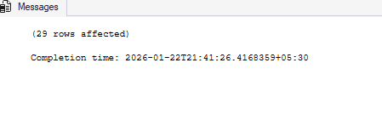

-- Creating Schema
--Dimension Tables
--Date Table
CREATE TABLE dim_date(
date_id INT IDENTITY(1,1) PRIMARY KEY,
Full_Date DATE,
Year INT,
Month INT,
Day INT,
Week INT,
Quater INT,
Month_Name VARCHAR(20)
)
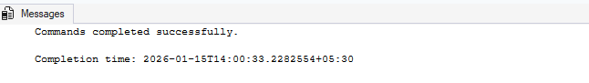
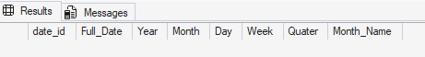

--Location Table
CREATE TABLE dim_location(
location_id INT IDENTITY(1,1) PRIMARY KEY,
State VARCHAR(100),
City VARCHAR(100),
Location VARCHAR(200)
);

--Restaurant Table
CREATE TABLE dim_restaurant(
restaurant_id INT IDENTITY(1,1) PRIMARY KEY,
Restaurant_Name VARCHAR(200)
);

--Category Table
CREATE TABLE dim_category(
category_id INT IDENTITY(1,1) PRIMARY KEY,
category VARCHAR(200)
);

-- Dish Table
CREATE TABLE dim_dish(
dish_id INT IDENTITY(1,1) PRIMARY KEY,
Dish_Name VARCHAR(200)
)

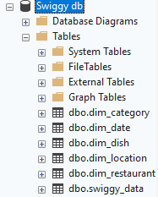

--Fact Table
CREATE TABLE fact_swiggy_orders(
order_id INT IDENTITY(1,1) PRIMARY KEY,
date_id INT,
Price_INR decimal(10,2),
Rating decimal(4,2),
Rating_Count INT,

location_id INT,
restaurant_id INT,
category_id INT,
dish_id INT,

FOREIGN KEY (date_id) REFERENCES dim_date(date_id),
FOREIGN KEY (location_id) REFERENCES dim_location(location_id),
FOREIGN KEY (restaurant_id) REFERENCES dim_restaurant(restaurant_id),
FOREIGN KEY (category_id) REFERENCES dim_category(category_id),
FOREIGN KEY (dish_id) REFERENCES dim_dish(dish_id)
);

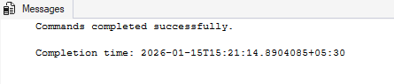
--Insert data into tables
-- dim_date
INSERT INTO dim_date (Full_Date, Year, Month, Month_Name, Quater, Day, Week)
SELECT DISTINCT
Order_Date,
YEAR(Order_Date),
MONTH(Order_Date),
DATENAME(MONTH,Order_Date),
DATEPART(QUARTER, Order_Date),
DAY(Order_Date),
DATEPART(WEEK, Order_Date)
FROM swiggy_data
WHERE Order_Date IS NOT NULL

SELECT * FROM dim_date
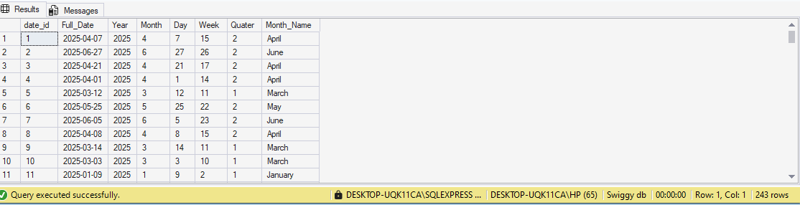

-- dim_location
INSERT INTO dim_location(State, City, Location)
SELECT DISTINCT
State,
City,
Location
FROM swiggy_data
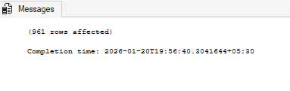
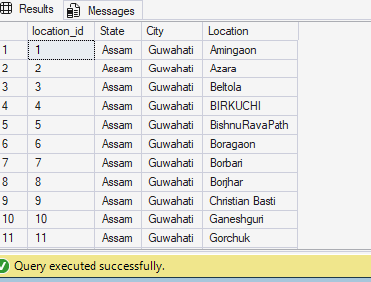

--dim_restaurant
INSERT INTO dim_restaurant (Restaurant_Name)
SELECT DISTINCT
Restaurant_Name
FROM swiggy_data
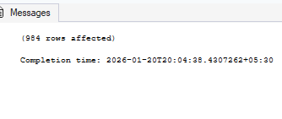
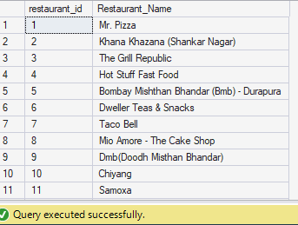

--dim_category
INSERT INTO dim_category(category)
SELECT DISTINCT
Category
FROM swiggy_data
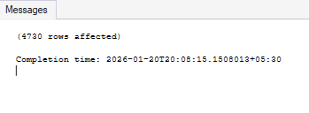
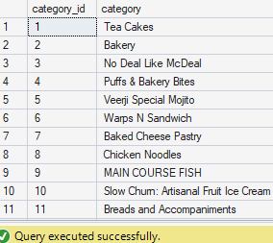

--dim_dish
INSERT INTO dim_dish(Dish_Name)
SELECT DISTINCT
Dish_Name
FROM swiggy_data
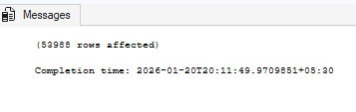
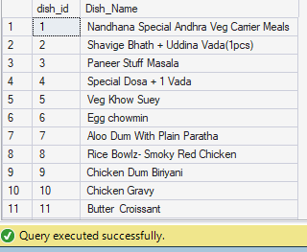

--fact_swiggy_orders
INSERT INTO fact_swiggy_orders(
date_id,
Price_INR,
Rating,
Rating_Count,
location_id,
restaurant_id,
category_id,
dish_id
)
SELECT
dd.date_id,
s.Price_INR,
s.Rating,
s.Rating_Count,

dl.location_id,
dr.restaurant_id,
dc.category_id,
dsh.dish_id
FROM Swiggy_Data AS s

JOIN dim_date AS dd
ON dd.Full_Date = s.Order_Date

JOIN dim_location AS dl
ON dl.State = s.State
AND dl.City = s.City
AND dl.Location = s.Location

JOIN dim_restaurant AS dr
ON dr.Restaurant_Name = s.Restaurant_Name

JOIN dim_category AS dc
ON dc.category = s.Category

JOIN dim_dish AS dsh
ON dsh.Dish_Name = s.Dish_Name
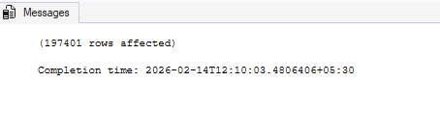

SELECT * FROM fact_swiggy_orders f
JOIN dim_category c ON c.category_id = f.category_id
JOIN dim_date d ON d.date_id = f.date_id
JOIN dim_dish dsh ON dsh.dish_id = f.dish_id
JOIN dim_location l ON l.location_id = f.location_id
JOIN dim_restaurant r ON r.restaurant_id = f.restaurant_id

--KPI's
-- Total Orders
SELECT COUNT(*) AS Total_Orders
FROM fact_swiggy_orders
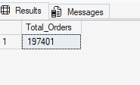

-- Total Revenue (INR Million)
SELECT
FORMAT(SUM(CONVERT(FLOAT, Price_INR))/ 1000000, 'N2') + 'INR Million' AS Total_Revenue
FROM fact_swiggy_orders
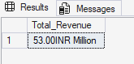
-- Average Dish Price
SELECT
FORMAT(AVG(Price_INR), 'N2') + ' INR' AS Average_Dish_Price
FROM fact_swiggy_orders
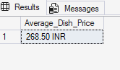

-- Average Rating
SELECT
FORMAT(AVG(Rating), 'n2') AS Average_Rating
FROM fact_swiggy_orders

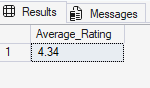

--Deep-Dive business Analysis/ Granularity level
-- Monthly Orders Trends
SELECT
Year,
Month,
Month_Name,
COUNT(*) AS Total_Orders
FROM fact_swiggy_orders f
JOIN dim_date d ON f.date_id = d.date_id
GROUP BY Year,
Month,
Month_Name
ORDER BY COUNT(*) DESC
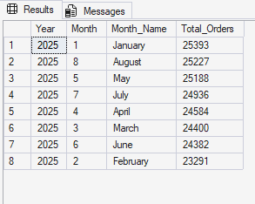

--Monthly Revenue Trends
SELECT
Year,
Month,
Month_Name,
FORMAT(SUM(CONVERT(FLOAT, Price_INR))/1000000, 'N2') + ' INR' AS Total_Revenue
FROM fact_swiggy_orders f
JOIN dim_date d ON f.date_id = d.date_id
GROUP BY Year,
Month,
Month_Name
ORDER BY
FORMAT(SUM(CONVERT(FLOAT, Price_INR))/1000000, 'N2') + ' INR' DESC
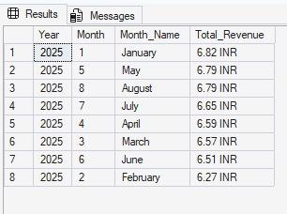

-- Quaterly Order Trends
SELECT
Year,
Quater,
COUNT(*) AS Total_Orders
FROM fact_swiggy_orders f
JOIN dim_date d ON f.date_id = d.date_id
GROUP BY Year, Quater
ORDER BY COUNT(*) DESC
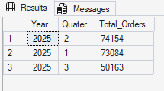

-- Quaterly Revenue Trends
SELECT
Year,
Quater,
FORMAT(SUM(CONVERT(FLOAT, Price_INR))/1000000, 'N2')+ ' INR' AS Total_Revenue
FROM fact_swiggy_orders f
JOIN dim_date d ON f.date_id = d.date_id
GROUP BY Year,
Quater
ORDER BY Total_Revenue DESC

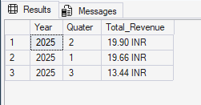

--Order by Day of Week (Mon-Sun)
SELECT
DATENAME(WEEKDAY,d.full_date) AS day_name,
COUNT(*) AS total_orders
FROM fact_swiggy_orders f
JOIN dim_date d ON f.date_id = d.date_id
GROUP BY DATENAME(WEEKDAY,d.full_date)
ORDER BY total_orders DESC

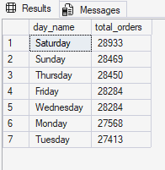

--location base analysis
-- top 10 cities by order volume
SELECT TOP 10
l.city,
COUNT(*) As Total_Orders
FROM fact_swiggy_orders f
JOIN dim_location l
ON l.location_id = f.location_id
GROUP BY l.city
ORDER BY Total_Orders DESC

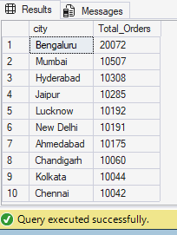

-- Bottom 10 cities by order volume
SELECT TOP 10
l.city,
COUNT(*) As Total_Orders
FROM fact_swiggy_orders f
JOIN dim_location l
ON l.location_id = f.location_id
GROUP BY l.city
ORDER BY Total_Orders ASC

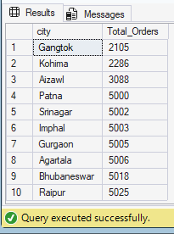

--Revenue Contribution by States
SELECT
l.State,
FORMAT(SUM(CONVERT(FLOAT, f.Price_INR))/1000000, 'N2') +' INR' AS Total_Revenue
FROM fact_swiggy_orders f
JOIN dim_location l
ON f.location_id = l.location_id
GROUP BY l.State
ORDER BY Total_Revenue DESC

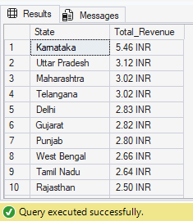

--Top 10 Restaurants by orders
SELECT TOP 10
r.Restaurant_Name,
COUNT(*) AS Total_Orders
FROM fact_swiggy_orders f
JOIN dim_restaurant r
ON f.restaurant_id = r.restaurant_id
GROUP BY r.Restaurant_Name
ORDER BY Total_Orders DESC
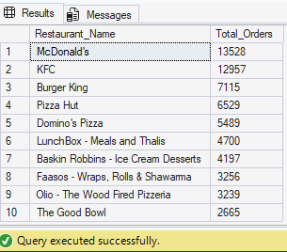

--Top 10 Restaurant by revenue
SELECT TOP 10
r.Restaurant_Name,
FORMAT(SUM(CONVERT(FLOAT, Price_INR))/1000000, 'N2')+' INR' AS Total_Revenue
FROM fact_swiggy_orders f
JOIN dim_restaurant r
ON f.restaurant_id = r.restaurant_id
GROUP BY r.Restaurant_Name
ORDER BY Total_Revenue DESC
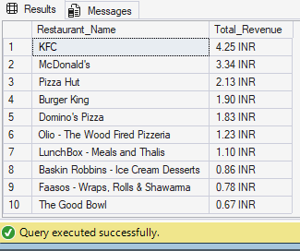

--Top categories by order volume
SELECT
c.category,
COUNT(*) AS Total_Orders
FROM fact_swiggy_orders f
JOIN dim_category c
ON f.category_id = c.category_id
GROUP BY c.category
ORDER BY COUNT(*) DESC

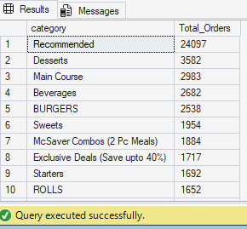

--Most Ordered Dishes
SELECT
dsh.Dish_Name,
COUNT(*) AS Total_Orders
FROM fact_swiggy_orders f
JOIN dim_dish dsh
ON f.dish_id = dsh.dish_id
GROUP BY dsh.Dish_Name
ORDER BY Total_Orders DESC

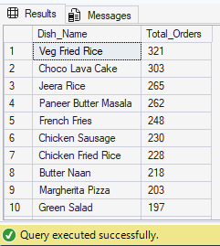

--Cuisine Performance (Orders + Avg Rating)
SELECT
c.category,
COUNT(*) AS Total_Orders,
FORMAT(AVG(Rating), 'N2') AS Average_Rating
FROM fact_swiggy_orders f
JOIN dim_category c
ON f.category_id = c.category_id
GROUP BY c.category
ORDER BY Total_Orders DESC
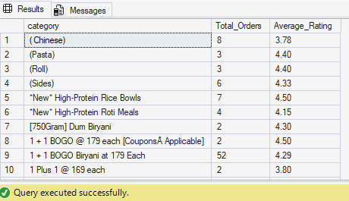

--Customer Spending Insights
--Total Order By Price range
SELECT
CASE
WHEN Price_INR <100 THEN 'Under 100'
WHEN Price_INR BETWEEN 100 AND 199 THEN '100-199'
WHEN Price_INR BETWEEN 200 AND 299 THEN '200-299'
WHEN Price_INR BETWEEN 300 AND 399 THEN '300-399'
WHEN Price_INR BETWEEN 400 AND 499 THEN '400-499'
ELSE '500+'
END AS price_range,
COUNT(*) AS Total_Orders
FROM fact_swiggy_orders
GROUP BY
CASE
WHEN Price_INR <100 THEN 'Under 100'
WHEN Price_INR BETWEEN 100 AND 199 THEN '100-199'
WHEN Price_INR BETWEEN 200 AND 299 THEN '200-299'
WHEN Price_INR BETWEEN 300 AND 399 THEN '300-399'
WHEN Price_INR BETWEEN 400 AND 499 THEN '400-499'
ELSE '500+'
END
ORDER BY Total_Orders

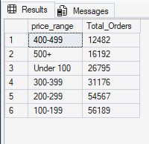

-- Rating Count Distribution (1-5)
SELECT
rating,
COUNT(*) AS rating_count
FROM fact_swiggy_orders
GROUP BY rating
ORDER BY rating_count DESC

